

Business System Design

For

Space Range and Display

- Store Range System

Version: 1.2 For Sign off

Authority:
Signature:
Authority:
Signature:
Authority:
Signature:

Contents
1. Introduction 4
2. Overview 4
3. System Description 6
3.1 Load Centrally Proposed Range for Stores 6
3.2 Update the Centrally Proposed Range 7
3.3 Maintain Local Store Range (Actual Range) 10
3.4 Identify Changes to Stocked Range 11
3.5 Maintain Capacity 13
3.6 Identify Range and Display extract for Shelf Edge Labels 15
3.7 Send Full Update of Location Sequence to StoreLine 17
3.8 Maintain Item/location status 18
3.9 Tactical Solution to Manage Local Discontinuations – Version 1 solution only 19
4. Interfaces 20
5. Assumptions 21
6. Appendix 1 – Calendar of communication from Store Range 22
7. Project Phase Sign-Off 23

Document Control

Project: | Project Name
Document Title: | Business System Design
Document Location:
Distribution: | Project Library – Docshare  Clive Mizen  Hilary Waterhouse  Samantha Baptiste  Eva Hotmarova  Steve P Miller  Jun Huang  GFO Team | Mary Welch  John Cowper  Jim Jeffery  Jon Braggs  Narendra Mohan  Srikanth Rangarajan  Rahul Bandhari  Emma Kenyon  Gary McLellan

Change Record

Date | Author | Change Description | Version
02/03/07 | Jacqueline Thomson | Initial draft | 0.1
16/03/07 | Jacqueline Thomson | Draft for initial IT review | 0.2
20/03/07 | Jacqueline Thomson | Feedback from IT Team, More details clarified. | 0.3
02/04/07 | Jacqueline Thomson | Feedback from Business Team. Sign off agreed on basis of wording changes. SEL section completed – Changes Tracked | 1.0
07/04/07 | Jacqueline Thomson | Updates following technical discussion with John Cowper and Clive Mizen. Added: section 3.10-reference data. Changes from V1.0 accepted – further changes tracked. | 1.1
26/04/07 | Jacqueline Thomson | Tracked changes. BSD updated to include logical data model. Clarification of business rules for SELs extract and confirmation of interface layout | 1.2

Introduction

The objective of this document is to detail the system requirements needed to satisfy requirements gathered in the BRD for Store Range V0.3 by Jacqueline Thomson. The sign off of this document will pave way for commencement and completion of the Technical design Document.

Overview

The Space Range and Display business process aims to ensure that the correct product range is in the correct store using the right amount of space in the store to optimise sales and the customer shopping experience. The IT systems that support the business process within Space Range and Display are made up of package solutions with Tesco defined modifications and Tesco own developed systems. In order to ensure the information produced from the central systems a need has been identified for a system that will be the gateway to downstream systems ensuring that there is one point of truth for space range and display information reaching other Group systems dependant on store range information.

The delivery of the Space Range and Display Store Range System will support the following functionality in Version 1:
- Maintenance of Centrally proposed ranges for store
- Maintenance of Local (Actual) Range for a store
- Identification and communication of changes to Stocked Range (for replenishment systems)
- Maintaining and communicating planogrammed capacities (for replenishment systems) and supporting the new stores opening process
- Identification and communication of Range and Display indicators for Shelf Edge Labels
- Passing location sequence for Price Integrity process to StoreLine system
- Maintenance and refresh of range data for item location status in ORMS
- In Store merchandising conformance reporting
- Tactical solution to manage high wastage lines and remove from centrally proposed range

The following functionality will be defined and delivered as part of the Version 2 Space Range and Display solution:
- Retail Range reporting for stores
- Managing local range choices

The design to support the above functionality from the Space Range and Display perspective will be included within this document. The Version 2 deliverables will include the functionality defined as out of scope for V1.

The following diagram is a representation of the Level 2 SIPOC system processes that will be met within this document. The system description in section 3 of the document will describe the system requirements necessary to support the business requirements document and meet the high level system requirements shown in the diagram.
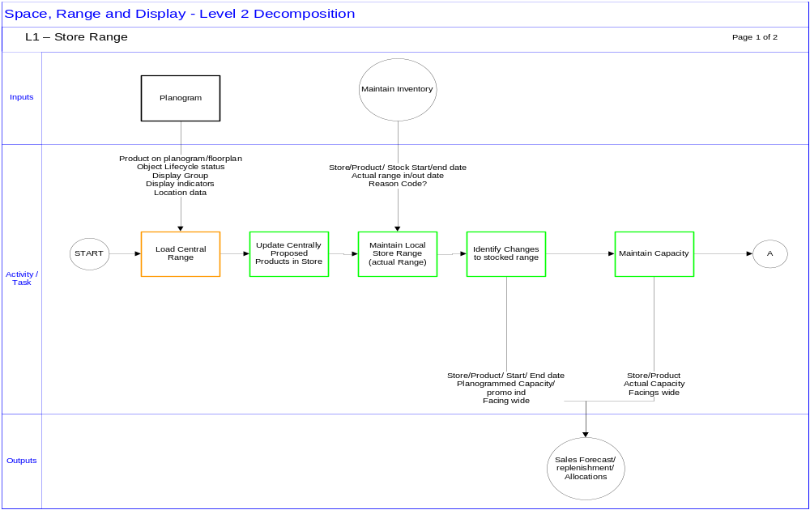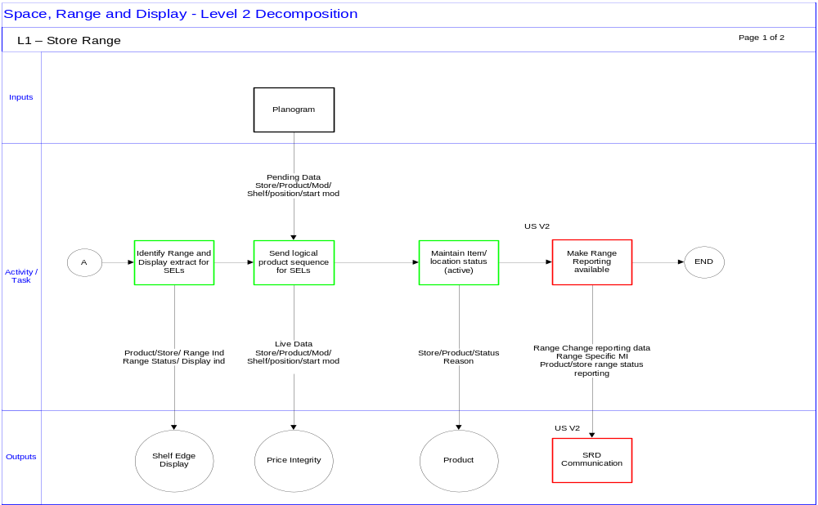

System Description
The assumption when reading the following document is that table and parameter names will be finalised in the Technical Design Document and names used within the BSD are for guidance only.

Load Centrally Proposed Range for Stores

The Store Range System must hold and maintain an accurate and up to date picture of the proposed range that a store should be stocking. The information that is necessary for this will be sourced from the JDA system, more specifically the IKB database (intactix Knowledge Base) that holds and maintains the data from the planogram and floor plan systems.

By associating a set of planograms to a floorplan the IKB database will know what the proposed range for a store is by associating the products on the planogram with the store number of the floorplan. It is logical then that the Store Range system will receive the centrally proposed range for a store from the JDA system.

On a nightly basis when the object lifecycles process has run in the JDA toolset, there will be an extract that is run from the IKB database. The extract will identify where the status of a planogram has moved to a pending status. There is an expectation that the planogram and floorplans will move to “pending” status within Object life cycles at 22 days before the date at which the planogram and/ or floorplan will move to “Live”.

The data that the JDA system will send to Store Range will consist of all products in a store’s range where any change has happened within the store. The system will send the whole product/store list where the store is on the extract. This will provide the Store Range system will an accurate picture of the centrally proposed range for a store.

The file will be sent to the Store Range System from JDA and will contain the following fields.

Field | Description
Store No | Retail Outlet number of store
Product Code | Tesco item number
Display Group | Display Group code
Planogram ID | Unique number identifying planogram
Promotional indicator | Indicator highlighting if planogram is promotional planogram/space
Capacity | Cube value (facings wide x high x deep) of product on planogram.
Facings wide | Number of facings wide as per the Planogram – this value may be null where the product is on multiple shelves on a planogram and the value is not equal on each instance of the product
Number of Labels | The default number of labels that will be required to be printed for the product in store
Multilocated Indicator | This will indicate if the product is multi located in the store
SRP Indicator | shelf ready packaging indicator
Live Date | This is the date at which the planogram or floorplan will be live in the store.

Please Note that the Live Date from JDA is logically the live date of the changes being made. In some cases where a space change has happened and the change is to a floorplan the live date will represent the live date of the change. Similarly where there are range changes and a change to the planogram then the live date will be the live date of the planogram in the store. The live date of floorplans and planograms will be the live date of the event in the SRD Event schedule that drives the change. In the case of new stores, the floorplan live date will be the date on which the store opens its doors to customers.

The information will be published from JDA on a daily basis to the Store Range system based on the change in status to “pending”. Where there are no changes for a store then the file will contain store ID only.

Where the Store Range System identifies that records for a store exist then the system must load the data into the Proposed Product in Store table.

The store Range system will be able to identify where a store is new by reading the store number for the first time on the JDA file. In order to ensure that this is captured to support the New Store’s process then the system must maintain a table of store IDs.

Update the Centrally Proposed Range
Where the Store Range system has identified a file to load into the proposed product in store table then the system must update the table appropriately. Please see the TSD for the mechanism by which to load the data into the physical database tables.

The fields held in the table are as follows:

Proposed Product In Store
Field | Key | Description
Store | Yes | 01234 – Tesco unique Store ID
Product | Yes | 1562321456 – Tesco Product ID (SKU ID)
Display Group | Yes | A1A – 2 digit alphanumeric Display Group code
Planogram ID | Yes | TBD – Alphanumeric unique identifier of a planogram
Range Start Date | Yes? | DDMMYYYY – the date that the product first appears on the planogram / display group in a store.
Range End Date | No | DDMMYYYY – the date that the product is discontinued from the planogram / display group in the store
Capacity | No | 00000 – the capacity is the amount of product that can be physically put on the shelf and is result for cubing (calculation of facings wide x facings deep x facings high)
SEL Facings | No | 00 - This is the number of facings wide that will be shown on the planogram and should appear on the shelf edge label
Promotional Indicator | No | Y – The promotional indicator will be passed from JDA and will indicate if the store/product/planogram ID record is from a promotional space and promotional planogram in store
Number of Labels | No | This value will be passed from the JDA system and will represent the number of minimum labels that are required based on knowing how many shelf locations the product may be on in a store
Multi location | No | Indicator to identify if the product is multi located in store
Shelf ready packaging indicator | No | JDA will pass if the item is in a tray pack and should be merchandised in this way
Record updated | No | DDMMYYYY – this is the date at which the system updated the record in the Proposed Product in Store Table
Reason Code | No | Centrally proposed range updated by JDA interface or by tactical local discontinuation solution.

Please note that the physical data model will differ from the table above – however a view of the data as per the table above is required in order to load the inbound file from JDA in order to ensure the system manages the dating process of products in store as per the rules described in the following section.

There will be one instance of store/product/planogram ID within the table since all attributes of the product in the store will occur at product on a planogram in a store level. The file from JDA may contain a planogram ID multiple times since the product on the planogram could appear in multiple locations throughout the store. Cases where this might happen are cases such as the chewing gum rack that can be found at every checkout counter. Store Range is only concerned with the range start and end dates and so where this occurs the system will only require one instance of the product/planogram ID/store occurrence. The value in facings/capacity for the product on the same planogram ID should be aggregated in order to only show total capacity for the product in the store. The value for facings will be equal in each planogram since the planogram ID is the same and the assumption is that any facings on the planogram for a product will be equal across all planogram instances.

There is an assumption that where a planogram is updated and new products are added or removed from the planogram then that the planogram ID will remain the same. If a planogram ID exists in the store and the planogram is changed then the changes are identified by comparing the store/planogram ID on the inbound file with the store/planogram ID already existing in store. If products are discontinued then they will not appear on the most recent planogram ID for the planogram from which they have discontinued.

If the new planogram does not use the same planogram ID as the old one, then discontinued products can still be identified as the IKB system is passing the entire store range data so if a planogram ID does not exist within the new range for a store then this will be identified.

Additions to the Centrally Proposed Range for a store

Any additions to the centrally proposed range for a store will be at the Store/Planogram/product level

The system must identify products on the inbound file that do not exist in the current Proposed Product in store table. In order to identify products that are new to the store, then for each store the system must look for records where the store/product/planogram ID combination for a record on the inbound file does not exist on the current Proposed Product In Store table.

Where products are found that match this criteria then they must be added as a new record for the store. The range start date of the product will be set to the Planogram Live date on the inbound file.

Another record type that will need to be added to the table are records for products that have been added to a new planogram in a store but have already previously existed in store on a different planogram.

Where products are on the inbound file and they have an entry in the proposed product in store table but match on Store/product combination only then the new instance of the product in the store on another planogram ID must be added to the store. The range start date of this instance of the product will be the live date of the planogram on which is is new to.

Deletions from the Centrally Proposed Range for a Store

Any deletions from the centrally proposed range for a store will be done at the Store/product/planogram level.

Where a product exists on the proposed product in store file but does not exist on the inbound file for a product/store/planogram combination then an end date will need to be set against the product/store/planogram ID combination on the Proposed Product In Store table. By matching on Store/Product/Planogram ID it is expected that all instances where the product is being removed from a planogram will be identified and have an end date set.

In this case, since there is no planogram with the product on it, the end date of the product will use the most recent planogram live date on the inbound file. There is an assumption that the most recent planogram live date will be the live date of changes that were driven from the change in status of a planogram to “pending”.

Where products are ending on some planograms but not all planograms in the store then by the above process then only the products that are actually not on a specific planogram will be end dated leaving products that continue to exist on other planograms in the “Proposed Product In Store” table.

Existing Products – display attribute updates

Where a product has been updated in the planogram but the status of new/discontinued has not changed then the details must be updated when loading the file into the Proposed Product in Store table. In this case where the planogram live date is greater than business date(current date of the store range system) then for every case where the Store/product/planogram ID is on both the existing Proposed product in store table and the inbound file from JDA the system must ensure the values for all attributes of the product are equal and where they are not, update the records accordingly.

In this case the system must not make any amendments to the start or end dates that exist in the proposed product in store table.

In all cases where updates are made to the proposed products in store table then the system must update the modified date of the record with the current business date. This is true also where the system has added or discontinued products in the store’s centrally proposed range.
It is suggested that once a week a snapshot of the table is taken and held for a week in order to provide a last known picture of Proposed Product in Store for support reasons. It is believed that this will also support the testing phase of this product. The exact timing that this snapshot is to be taken is yet to be defined.

The timetable of scheduled tasks within the Store Range system will be defined at length within the technical design document. The data will be stored in a table that is a copy of the structure of the Proposed Product In Store table and will be called “Proposed Product In Store_History”. Each week this history will be overwritten with the next snapshot. It provides the system with a mechanism to roll back to last known range in case of system errors/issues.

New Store Additions

Where stores are existing stores for which Store Range system held a previously centrally proposed range then the above process to assign range start and end dates for products in those stores is logically correct. However, the live date Store Range will receive for a floorplan/planogram where a store is a new store will be the Store Opening date.

Essentially the Store Range system will receive the entire store range for the new store. This will be 3 weeks before the opening date of the store. By the point at which the store opens to the customers it must be fully merchandised and stocked and since Store Range communicates the live date of the change as the first day on which stock needs to be delivered to store the standard process of using the live date of the floorplan/planograms will not be sufficient enough to ensure stock is in store on the day of opening.

In order to satisfy the requirement to “skim and fill” (process by which replenishment can stock a new store and fully merchandise) the Store Range system must assign a range effective start date for the products in the store that allows ordering to begin earlier than the usual time period for new stores only.

The Store Range System must therefore assign a range Start date that is sooner than the opening date of the store. In order to assign a range start date to the product in the store the system must add 3 days (exact value to be defined) to the current business date that the file is processed on. This value will be held as a parameter and will be set by the business team.

Where there is a range change on planograms assigned to the floorplan for the new store then the planograms will only include products that will exist on the planogram when the store opens. Therefore the system does not need to identify products that are being discontinued within new stores.

However, in the following week there may have been range changes that mean there could be products ending in week 1 of the store being opened and trading. The assumption is that this is acceptable and will be managed in store as part of “business as usual”. This assumption will be clarified once the business decision about how to manage range changes for new stores in week +1 and 2 has been agreed.

Maintain Local Store Range (Actual Range)

On a daily basis before 6am in the morning (exact timing to be confirmed) the GFO system will extract all changes to product/ store data and send SRD system details of stock records for products in store.

The system must identify changes to the following fields for every product in every store:
- Stocked Start date
- Stocked End Date
- Actual Range In Date (date that bookstock of product first registered)
- Actual Range Out Date (date that bookstock returned to 0)
- Stock Reason Code (if available in GFO)

The table is expected to contain the following fields:

Product In Store
Field | Key | Description
Store | Yes | 01234 – Tesco unique Store ID
Product | Yes | 0562321456 – Tesco Product ID (SKU ID)
Stocked Start Date | Yes (TBC) | DDMMYYYY – Start date of when product was ordered for stores. There is an expectation that these dates should mirror what was sent to GFO where the SRD systems have been the trigger for products being ordered for a store.
Stocked End Date | No | DDMMYYYY – end date of product in Store as held in GFO. As above
Actual Range In Date | No | DDMMYYYY – this is the date at which a bookstock was registered as greater than 0 in store
Actual Range Out Date | No | DDMMYYYY – this is the date at which the bookstock of the product in the store reduced to 0
Stock Reason Code | No | A – this is the reason code to indicate why the product has been ordered for store. Currently this may not be available from the GFO system

Identify Changes to Stocked Range

The Group Forecast and Ordering (GFO) system have a requirement to receive updates from the Store Range system of products that are ranged in the store. GFO require this data 21 days before the start date of the product in order as the “order calculation” is based on a 21 days forecast. The Store Range system will not be passing a full refresh of range every evening but passing GFO a file detailing store specific changes to range. This feed must be daily to support the long term requirement to move to “day of week” merchandising.

To ensure we can support the requirement to send “new store” ranges to GFO it is also necessary to calculate store specific range changes on a daily basis. The date that the range will be effective for (for new store opening) may be less than 7 days from the current business date in the store range system and would therefore potentially not be picked up in a weekly calculation. This process will help ensure that Store Range picks up all range changes and will support business with shorter lead times for some product areas as well as support essential product launches and changes.

In order to derive what products should be ordered from the ordering system the Store Range System will be required to compare proposed product range for a store with products that the store are currently stocking. The difference of which will be communicated to Group Forecast and Order on a weekly basis. This extract should run during the evening once the update to proposed product in Store has been completed to ensure that the ordering system are getting 21 days worth of updates to new and discontinued products in a store. The exact timings of system processes will be defined and documented within the Technical Design of the Store Range System.

The time window that will be used to identify changes to the centrally proposed range for a store will initially be current business date + 21 days where 21 is a parameter held within the Store Range system.

The Data sent to GFO to support replenishment requirements will be sent at Store/Product Level. In version 1 the Store Range system will not be including Display Group code on the interface to GFO and therefore in Version 1 it is expected that there will be one instance of store/product combination on the output file to GFO.

This may be subject to change when and if GFO have a requirement to use the Display Hierarchy at a later stage.

The Store Range system must identify the following products:

New Products for a store

In order to identify new products for a store the system must first identify the products that should be in a store irrespective of planogram/ display group relationships.

The system must identify where a product has a start date that is less than or equal to business date + 21 days (as per parameter defined above). This logic could potentially pull out more than one record for the product in a store as the product already exists in another planogram or display group in the store.

If more than one record for the store product combination exists then the instance of the store Product combination that is the most recent date is the record that will be used to set the start date in the GFO system. The most recent date should be the date that is closest to the current system business date. The other instances of the product will either be historic products or products that exist on planograms that are already within the store’s range. This system process is required to identify that the store/product combination is in the proposed range for the store at the end of the activity window for replenishment (current date + 21 days).

Where the Store Range System writes a record for a Store/product/planogram ID into the GR replenishment extract the system must be hold an internal record in a history table. This is required to ensure that the system does not communicate the same change twice. For example, if the extract runs on week -3 and identifies any records with a range start date in week 0 then in week 2 when the extract runs the record will not be communicated again as it will be on the GFO replenishment _ history table within the Store Range System.

Discontinued Products for a store

In order to identify products that are discontinued for a store the system must first identify any product that has an end date that is less than or equal to current business date + 21 days. For all products identified with an end date in the replenishment activity window (timeframe of interest for calculation) the system must check that there are no store/product combinations in the proposed product in store table that have multiple records.

Where the store/product combination has multiple records the system must identify that all records have an end date that is within the activity window. If any records exist that do not have an end date at all, or any instances of the product have an end date that is greater than the activity window then the record should not be written to the extract file. The reason for this is if there are still instances of the product in a planogram in the store that do not have an end date yet, then the product should still be being ordered and replenished for the store .
The system will also ensure that where products have an end date within the window, if the product already exists on the output file as a product that has a start date within the window then the end date will be written on the store/product record. This will manage any products that have a start date and an end date within the activity window and ensure no duplication on the output file.

As with new products any product identified as a discontinued product should be written to the GFO replenishment _ history table.

Building the replenishment extract

Once the file of products that are new and discontinued to all stores has been identified then the system must identify the correct products to be communicated to the ordering system. In order to support this then the system is required to make a comparison between the centrally proposed range for a store and the actual range already being stocked in the store.

Where the product exist in centrally proposed range and has a start date within the activity window (and has been identified as a new product) then the system will identify if the product/store combination exists in the actual Range table. If the product is currently being stocked in the store, i.e., has a valid stock start date and end date is greater that activity window or null then the product will not be communicated to the GFO replenishment system.

Where products are discontinued from the proposed range (and have been identified as a discontinued product) then the system must read the Product In Store table. Where the product does not exist as part of the stocked range and has no stock start date or end date then the product will not be communicated as a discontinued product to GFO as it is not being stocked in the store. Where products not currently stocked have values in the start and end date fields then the following rules must be applied to identify the correct product status in store. A product that is not stocked:

Can have no start date and no end date, or
A start date that is historic (less than current business date) and an end date that is less than or equal to the end of the activity window.
A start date that is in the future and set for a date greater than the end of the activity window,

If a product is identified as discontinued in the centrally proposed range falls into one of the categories above then do not communicate the product as discontinued.

The data will be sent to the Integration layer and then passed onto the replenishment system.

The file that will be sent to the integration layer from Store Range for GFO replenishment will be as follows:

Field | Description
Store No | Retail Outlet number of store
Product Code | Tesco item number
Display Group | This field will be null in SRD Version 1
Range Effective Start Date | Centrally proposed start date of the product in the store
Range Effective End Date | Centrally Proposed end date of the product in the store

The GFO system is based on the UK CR system and as such they are retaining existing UK interface file layouts. There is an assumption that where store range is unable to provide data for a field that GFO expect then GFO will ensure that they can still load and process the file. Where they are unable to do this then GFO and integration are responsible for finding a solution.

Maintain Capacity

Providing GFO with Planogrammed Capacities

The feed of capacities will be sent to GFO on a separate extract file. The reason for this decision is that the extract for replenishment data is start and end dates for a product in a store and a record should only appear once for a store/product combination. The capacity file however, can have two records for a store/product combination where the product is place on multiple planograms and one of those planograms is a promotional planogram.

The Store Range system must communicate planogrammed capacities to the replenishment system and identify capacities of products on a promotional planogram in a separate record to GFO.

Capacities will be sent to the GFO system 21 days in advance of the date at which the change will be live in store. The replenishment team will not use this capacity until 2 days before the effective date on the file as the GFO system is currently unable to handle future dated changes and will use the value sent by range in the order calculation immediately. Please note that this is a GFO specified rule and this parameter is independent of Store Range system.

The store Range system must identify any changes to the capacity for a product in a store. Where the product is on multiple planograms then the sum of all the capacities must be added together and sent to GFO as a total. The system must therefore identify all records in the centrally proposed range where the range effective start date is less than or equal to the business date + 21 days (end of the activity window and held as a parameter) and the end date of the product is null or greater than the end of the activity window. This will return all records for the product in the store on the various planograms.

Where the promotional indicator for products in the centrally proposed range for the store equals N then the capacity for the same product in multiple planograms will be added together and this is the value that will be sent on the extract file. This is true except where the Store/Product/Planogram ID has a Promo Indicator equals to Y against it in the centrally proposed range attributes. Promotional capacities will be sent on a different record on the file as these are handled separately within the GFO system.

Each week, where there has been a change to a capacity for a product on a planogram then the system must perform the calculation to identify total capacity for the product in the store. In order to ensure that the system can identify all instances of a product change then the calculation should be done for all products where one instance of the product was updated in the most recent JDA upload. This can be identified by using the modified date of the store/product/planogram where the modified date is equal to business date on which the JDA update to store range was processed.

The system must also identify the number of facings of the product. GFO do not use this data but it is a historical requirement based on an existing UK interface. Store Range is only able to send number of facings of a product where the product has the same number of facings across all instances of the product used in the calculation of capacity. The number of facings is passed at planogram level. If a product in a planogram is on two shelves within that planogram and the number of facings on each shelf is not equal then the value received from JDA for this product will be 0.

It is expected that Store Range will pass the following fields to GFO:

Field | Description
Store No | Retail Outlet number of store
Product Code | Tesco item number of base product
Promotional indicator | Indicator highlighting if planogram is promotional planogram/space
Capacity | Cube value (facings wide x high x deep) of product on planogram
Facings wide | Number of facings wide as per the Planogram – this value may be null where the product is on multiple shelves on a planogram and the value is not equal on each instance of the product
Effective Date | The date on which the capacity is considered to be live in store

Communication of Capacities Captured at the Shelf Edge

Communication of capacities captured at the shelf edge is the responsibility of the Record Product Position application and therefore does not need to be documented in this Business Systems Design. The “Record Product Position” application must ensure that the interface sent to GFO is in the same format as above in order to ensure that the GFO system can load the data irrespective of where the capacity is sourced from.

Identify Range and Display extract for Shelf Edge Labels

Range Indicators

On a daily basis the system will extract the correct indicators to send to the Retail system, StoreLine in order to facilitate writing the correct indicator to the Shelf Edge Label.

Within the range indicators there are two indicators that play a part in determining what should be shown on the label with respect to range. There is the Range Indicator and the Product Status indicator. The Range indicator will identify where a product is

- In Central Range – ie part of the centrally proposed range for the store,
- Not Ranged – does not belong in the store anywhere
- In Local Range – part of the range locally defined by the store (this is out of scope for the V1 release and current release of Store Range)

The Product Status indicator will identify the following products:

- New -products that are new to the stores range
- Discontinued – products that are being discontinued from the store’s range and
- Standard – products that are neither new nor discontinued and are regularly ranged products.

Determination of range indicators

In the initial build of the extract to SELs we only have the potential to have “In central Range” and “Not ranged indicators”. In order to determine the value the business rules that will be followed are found below.

A product is in the centrally proposed range when the range effective start date of the product in a store is equal to business date +1 and the range effective end date of the product in the store is null or greater than the range effective start date. There may be a historical end date but this date must be less than the range effective start date of the product.

A product is not ranged when the range effective end date is greater than the range effective start date of the product and, the range effective end date is equal to business date +1.

When the case is as above then the product will be extracted to the SEL output file with the appropriate indicator.

0 – Not Ranged
1 – In Central Range

The extract of these dates will be identified one day in advance where the relevant time period is “business date + 1” the value of 1 will be held as a parameter. It is highly unlikely that there will be business need to change this value since by using the value of 1 we ensure that the range status will be effective in the Shelf Edge Label System on the date on which the product range status is effective, i.e. on range effective start and/or end date.

In order to identify the correct status for these products the system must build a picture of centrally proposed product in Store and identify the correct range effective dates for the product in the store and not the product on the planogram as product on planogram could produce multiple values for range status depending on the status of a product on a planogram and not a product in a store.

Product Status Indicators

In order to identify the correct status for a product in a store the system must be able to recognise and manage specific scenarios. The first scenario that must be managed is for new stores.

New Store Opening

For new stores the system must generate and understand the range status of products in a store but must not pass these out. For every extract that the system builds Store Range must identify which stores are new stores. This can be determined by referencing the store table. For any store that has an opening date of business date -30 days the system will not extract any changes to the product status of products in the store. This will be a parameter held and should always be related to the point at which the “new” indicator for a product is removed. The reason being that the system must also protect stores from a full flush of indicators as they attribute the correct value to products that exist in the store. When the system passes the 30 day parameter then from that point forward only changes to the product status attributes should be sent to StoreLine.

It should also be noted that if the store opening date is in the future then the status of new and discontinued will not be required to be extracted.

Please note that this is a tactical solution while the SRD design team designs the retail controls and settings application that will manage the extraction of SEL indicators for various store types. This new store rule will only apply to the product status indicator since the fact that a product is ranged or not ranged does not impact the customer perception of the status of a product in a store. The business are trying to manage the message of “new” and or “discontinued” to customers since for a new store all products in the store are essentially new to the customer.

New Products

The system must identify products that are new to the store.

The definition of a new product is a product that has a range effective start date in the activity window. There are several parameters around managing the message of new to a store. The system must firs identify any products that are new within the next 21 days. As above, the system is only concerned with products new to a store and must identify the range effective dates of the product in the store within the centrally proposed range and not the dates at which products move between planograms.

If the product has a range effective start date in the centrally proposed range where the range effective start date is current business date + 21 and the range effective end date is null then the product should be written to the extract as a new product.

Where the product has previously been in the store and there is an existing end date – if the end date of the product is not greater than current business date – 160 then the product will be communicated with the status of Standard. The value of 160 days will be held as a parameter which is used to determine the length of period since the product was last stocked.

Currently all validation for the extraction of these products is done against the centrally proposed range for the store.

Where the products that are new have all been identified a final check must be done against the product in store table in order to determine if there are any products flagged as new that are currently being stocked in the store. If there is a valid stock record for a product where the start date of the product is equal to or less than today and the end date of the product is null or greater than the start date then the product should not be written to the file as new. The business reason behind this is that when Space Range and Display is rolling out into existing businesses as we switch products to planograms they may already be physically stocked in store and being replenished through the Group Forecast and Ordering system. It is important that we don’t launch a planogram for a display group and communicate that all products are new since they are not new to the customer but simply new to the SRD process and planogram.

For products that are new products that move to discontinued within the activity window then the following must apply. Where the product has a start date of current date + 21 and there is an end date that is equal to or less than start date + 30 days then the product will be sent as a new and in centrally proposed range. The indicator for discontinued will not be sent until the business date + 1 is equal to the end date as a New indicator will always rule over discontinued.

In order to remove the New indicator in all other circumstances so when the product is now part of the store’s range then the system must identify all products in a store where the range effective start date of the product is equal to current date – 30 days where 30 is held as a parameter and can be subject to change.

Discontinued Products

The store range system is also responsible for communicating the correct discontinued indicator at the appropriate time. The system must be able to identify all instances where the product is being completely removed from the store. In this case where the range effective end date of the product is equal to the current business date + 21 then the product will be extracted to the file as a discontinued product. The system must ensure that there is no new start date in the future and if a start date for the product does exist in the centrally proposed range then the start date must be historic and less than the current business date.

There will be no system process to remove the indicator from the product on the PLU (price lookup file) in StoreLine since if an instance of the product does appear in store requiring a label then the correct indicator to be shown would be discontinued.

Relationship between range and product indicators

There is not direct relationship between the range and product indicators and as such they can both be reasons that different products are extracted to the outbound file. However, when extracting products that are new for the first time, the product must have a default of “Not ranged” set against it. One day before the start date of the product the system will extract the correct change to range status of “In Central Range” without generating a change to the product status. It must also be noted that when the product has been sent to StoreLine with the discontinued indicator 21 days in advance the range status will still be “in centrally proposed range”. At the point where the range status changes and now becomes “not in range” (this is where the range effective end date of the product is equal to Business date +1) then the planogram ID on the output file should be set to null. This will ensure that the products associated with the planogram ID when a user request labels by planogram are labels for products that are on a live planogram only and don’t continue to produce labels for products discontinued from the range.

Where the product is new and status of range is moving to “in centrally proposed range” then the planogram ID must be written to the output file.

There is an issue with respect to management of products on multiple planograms since the StoreLine system is unable to hold multiple attributes against the one product in store combination on the PLU (Price Lookup File). The suggested solution is that the following rules apply:

Where the product is on one planogramID then the planogram ID that the product is associated to in the store should be extracted to the output file.
Where the product is on two planograms and one of the planograms is a promotional planogram then the ID of the regular planogram should be extracted to the output file.
Where the product is on two regular planograms then no planogram ID should be written to the file is null until such a time that multiple planogram IDs can be held in StoreLine or there are change in business rules which means we can easily identify the correct or primary planogram ID for the product in the store to use.

The output file to the integration layer to support this requirement is expected to be as follows:
Field | Description
Store Id | Retail Outlet number of store
Product | Tesco item number of base product
Display Group | Display Group code
Planogram ID | Unique number identifying planogram
Range Indicator | 0 = Not In Range, 1 = In Centrally proposed range, 2 = In Local Range
Product Status | 0 = Standard, 1 = New, 2 = Discontinued

Display Indicators

The display indicators are held within the Store Range system at a planogram level. This must be aggregated up to be held or managed at store level. The reason that this is necessary is that StoreLine is currently unable to manage display attributes at product in planogram level and can only hold an attribute at product in store level. The store range system must therefore manage this aggregation.

The rule for extracting the correct indicator based on timings for display attributes is similar to that of defining change to range status. The system must identify the effective date of the change to display attribute. Where the current date +1 (where 1 is a parameter in number of days) is equal to the effective date of the display attribute in the store then this must be extracted to the file.

The system will hold the following display attributes:

- Number of facings wide
- Number of default labels
- Shelf Ready Packaging indicator
- Multi-located indicator.

These fields are passed from JDA at product on planogram level. There is a table that has been defined to hold these indicators. This table will hold the indicators at an aggregate level. The rules for populating the table are as follows.

Where the number of facings on each planogram location are equal then the system can write this value to the display properties table. Where the values are not equal then the system must leave the field for facings wide as null.

Where the number of default labels are greater than 1 then this means that the product is multilocated. The system must add the values for each number of default labels together and the total of which will be populated in both the multilocated field and the default number of labels field.

The shelf ready packaging indicator will be extracted to the table where the value is the same in all cases. Else the field will be left null.

The system must check the effective date for display properties and where the effective date is current date + 1 then the system must write these values against the correct product in store entry on the extract file. Else the fields can be left null on the outbound file.

The IDS will update the PLU file for StoreLine with the appropriate values and this will trigger the updated label(s) to be printed in store on the morning of the effective date of the change. The effective date will be the planogram/floorplan live date that triggered the change in value.

The outbound file will contain the following fields:

Field | Description
Store Id | Retail Outlet number of store
Product | Tesco item number of base product
Number of facings wide | The aggregate value for facings wide of the product in the store. It is expected to be null where the value differs for every instance of the product
Number of default labels | The number of total labels that need to be printed in the store. This value will be equal to the number of locations in the multilocated indicator
Multi located indicator | The number of locations that the product is in. If there is 1 then the value will be null in order to ensure that no indicator to suggest multilocation is on the label
Shelf ready packaging | This indicator defines if the product is to be merchandised on the tray pack or not. If there are more than one location and all values are not equal then this field will be null. Please note that StoreLine cannot read this field for the first release.

Please see the appendix which illustrates a calendar of timings for which indicators and communications will be passed to systems downstream of Store Range.

Send Full Update of Location Sequence to StoreLine

There is also a requirement from the StoreLine team that Space Range and Display will provide the retail team with a logical sequence order in which shelf edge labels will be printed in store when an update to price is being processed. This is in order to improve efficiency of the Price Integrity team. This requirement is still under discussions with the Retail IT team and until the time that the data required is agreed this area is subject to change.

The proposal from the Space Range and Display team is that we can provide product positioning on a floorplan and together with the starting mod of a planogram and number of mods in the planogram sequence then it is expected that a logical order of products can be derived.

The Space Range and Display team, however, are not able to order the file based on where mods are around a physical store and there may therefore be some processing on the StoreLine system to resolve this.

In order to support the requirement there is a need for the JDA system to pass Store Range an interface file product location in store information. As previously stated it is expected that this feed will be processed from JDA following the object lifecycles processing and will be triggered by a change to Pending status. As before the file will be passed nightly and it will only contain all records for those stores that have planograms or floorplans that have changed. For any store that is passed on the file with records the data will comprise all locations of products that are in the store at the live date.

The load process of this file is the same as the load of Store Range in the sense that the load process will update the file for all records that have changed. The expected data is as follows:

Field | Description
Store Id | Retail Outlet number of store
Product | Tesco item number of base product
Display Group | Display Group code
Planogram ID | Unique number identifying planogram
Facings wide | Number of facings wide on the shelf of the product
mod sequence | This is the number representing which mod on the planogram that the product is on
Shelf | This is a number representing the shelf on the planogram that the product is on
product sequence | This is the product sequence on the planogram on a shelf.
start mod | This is the mod that is the first mod on the planograms and can be directly associated with the mod on the floorplan.
Effective Date | The date at which the data in the file will be live in store

The layout of the table that will house the data above is expected to contain the same fields. . The reason for this decision is due to the nature and timings of the data being sent. When display and range indicators are being sent then they are based on pending planogram data and are sending the system an update of changes that will be happening in the future. The product position data as per the planogram is a reflection of data underneath live planograms and therefore represents what should be in store today on the assumption that the store follow the planogram. The Store Range System should pass all data for a store where the store has a record for a planogram with a live date of business date + 1 – this will ensure that the price changes that are received the following morning (when the planogram is live) will be sequenced according to the product positions that are live.

The Store Range Database does not need the information above for any other reason and it is suggested that the table holding the data remains similar to the interface file in. The interface out to storeline will be in the same format as the inbound file.

Maintain Item/location status

There are no requirements for any extra data to be fed into the Store Range system in order to meet this requirement.

Until Space Range and Display deploy in country then ranging is done within the ORMS system (oracle Retail Merchandising System). This means that the buyers in Commercial currently set up and maintain the item/location status to active/inactive. In order for products to be ordered then the status of a product for a store needs to be active.

When products in display groups roll onto the Space Range and Display systems and are ranged in these systems it means that Space Range and Display will be the master of item/location status for display groups/products rolled out and that are planogrammed.

The requirement is that every night there is a full refresh of range data to the ORMS system where both a reconciliation process will occur and an update.

The Store Range system must extract a picture of what is currently ranged in store and extract this to the file to send to ORMS.

Furthermore, in order to create new item/location relationships the system must identify products that have a stock start date business date +21 days (standard parameter). These products will be extracted to the file as active products and will update ORMS.

Where products have an end date in proposed product in store that is business date + 1 day then the product will be extracted to the file as inactive products and used to update the ORMS file.

The range effective start and end dates will be passed to the RMS system as the Order Review System required a picture of range to support manual ordering processes in Store where allowed.

The expected interface details are as follows:

Field | Description
Store Id | Retail Outlet number of store
Product | Tesco item number of base product
Status | A = Active and I = Inactive
Reason | 1 = Update and 2 = refresh
Range Start Date | The date from which the product is ranged in the store
Range End Date | The date from which the product ceases to be ranged in the store

Tactical Solution to Manage Local Discontinuations – Version 1 solution only

Within the Version 1 solution for the Space Range and Display operating model the business have identified that they require to support the discontinuation of products at a Store/product level where the stores are negatively impacted if they are required to stock a product that is costly to their business despite being part of the centrally proposed range for the store based on the store’s size and ranging attributes.

The Business will maintain a spreadsheet and a set of business rules that will determine which products can be discontinued at a store level. This will be manually maintained and the store range system does not need to understand the business rules used to make this decision.

The Store Range System must upload this data and be able to update the centrally proposed range for the store as a result of it. The upload will be on an ad hoc basis and will be managed by emailing the Store Range Support team to upload the file (held on an excel spreadsheet) as required. It is expected that the support team must upload the file within 24 hours of receipt.

The data held on the spreadsheet will be at Store/Product level and include the end date that the business wishes to use to discontinue the product. Where the product exists in the centrally proposed range for the store then the system must assign the end date on the spreadsheet to all instances of the product. There must be a reason code for the discontinuation in order to ensure that where updates to the centrally proposed range occur then this product is not added back into the centrally proposed range for the store.
The business team can remove the product from the spreadsheet if they believe that it should be re-introduced to the store. When the file is uploaded into the system then the system must assign a new start date to the product in the store. In order to support this, the business will be required to assign a start date to the product and indicate which planogram IDs the product still exists on in order to assign the product to the correct planograms.

The data stored in the spreadsheet must be used to update the centrally proposed range every time the table is updated by a new interface in from the JDA system. This should occur every night following the completion of updating the centrally proposed range. This will ensure that the product is correctly managed downstream and will provide a reference table for any exception or conformance reporting that is required to support Stores.
It is expected that the spreadsheet should contain the following fields and will be held in a table within the Store Range system in a similar manner:

Field | Description
Store Id | Retail Outlet number of store
Product | Tesco item number
End Date | A = Active and I = Inactive
Start Date | Start date if business wish to re-start product in store
Reason | W – wastage rounding R – Restarting product on planogram
Planogram ID | Where the business are restarting the product they must introduce the planogram ID they wish to have the product active on.

Please note that the exact mechanism to re-start products by this method is to be defined and agreed with the business team.

Reference Data Requirements
Within the Store Range system there needs to be reference data identified that will support future development required as well as ensure that the database has foundation data that supports managing new stores opening process. The data that has been identified is store data and product data. To support this the system requires an interface of store and product date from the IDS.

Store Data

The system requires a full picture of all stores within the country in which the system is deployed. The fields required are as follows:

Field | Description
Store Id | Retail Outlet number of store
Store Description | Store Name, this will support future reporting requirements
Store Format | Superstore, Metro etc
Store Live date | Opening date of the store
Store Trading Indicator | Whether the store is trading or in development

It is expected that the feed of Store Data will be a daily feed and include updates to store data. The table will be updated as and when there is an update available and the system should be able to cope with no updates or changes being available for stores.

Product Data

The system will also require product data which will be a feed of all products on the corporate product list. The fields required are as follows:

Field | Description
Product | Tesco item number
Product Description | 40 character product name

Product data should be updated as and when new products are available.

Interfaces
Interface Number |  | Description | From |  | To |  | Type
Physical | Logical | Description | System | Job | System | Job
INBOUND ←
S031 | S078 | Planogram Product Position | JDA |  | SR |  | Delta
S057 | S057 | Store Range | JDA |  | SR |  | Delta
S077 | S077 | Actual Range In Store | GFO |  | SR |  | Delta
S094 | - | Central Discontinuations | Excel |  | SR |  | Refresh
S089 | S089 | Store | IDS |  | SR |  | Refresh
S087 | S087 | Product | IDS |  | SR |  | Refresh
OUTBOUND →
S047 | S047  S050 | GFO Replenishment | SR |  | GFO |  | Delta
S095 | S051.1 | GFO Capacity | SR |  | GFO |  | Delta
S049 | S051 | SRD ORMS Status Update | SR |  | ORMS |  | Refresh
S039 | S039 | SEL Range | SR |  | Storeline |  | Delta
S092 | - | SEL Display | SR |  | Storeline |  | Delta
S093 | - | Location Sequence | SR |  | Storeline |  | Refresh

Assumptions

The following assumptions have been made in this document:

- Planogram ID of an existing and updated planogram is the same name as the previous planogram
- Changes to a floorplan will highlight range changes triggered by space changes for a store
- The parameter table will be defined within the Technical Design for the project.
- Downstream systems from SRD have no concept of product in shelf position level data and are currently unable to manage multilocated products.

Appendix 1 – Calendar of communication from Store Range

Please find below a calendar of communication activities from the Store Range System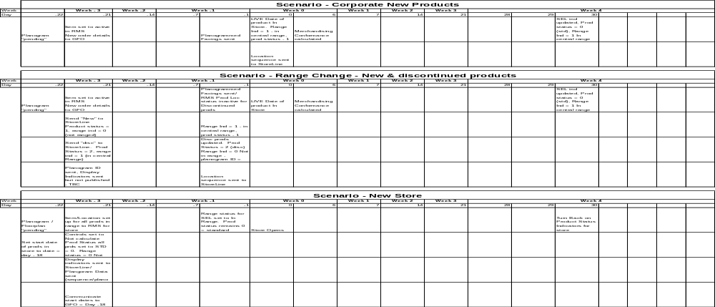

Project Phase Sign-Off

The sign off of this document is:

Eva Hotmarova - IT Business Systems Manager
John Cowper – IT solutions Architect
Emma Kenyon – IOD End to End design Manager for SRD
Janet Smith – IOD Space Range and Display Director
Steve P Miller – IOD Store Processes Project Manager

